Neuro-AI: Hybrid Model for Cognitive Enhancements

Dr. N. Sunanda
Assistant Professor
Dept. of CSE-(CyS DS) and AIDS VNRVJIET, Hyderabad, India .
nsunandapratap@gmail.com
E. Jafrash
Dept. of CSE-(CyS DS) and AIDS, VNRVJIET,
Hyderabad, India Email: jafrash123@gmail.com
M. Goutham
Dept. of CSE-(CyS DS) and AIDS, VNRVJIET,
Hyderabad, India
gajanagoud1432@gmail.com

G. Pranay
Dept. of CSE-(CyS DS) and AIDS, VNRVJIET,
Hyderabad, India gandhamanenip@gmail.com
K. Sathwik
Dept. of CSE-(CyS DS) and
AIDS, VNRVJIET,
Hyderabad, India sathwikkokkonda997@gmail.com

Abstract— While extended screen time, multitasking, and stress deteriorate focus and memory, modern academic and professional settings require sustained attention and quick learning. In order to infer cognitive states (high focus, low focus, and cognitive fatigue) and provide tailored micro-interventions like paced breathing, micro-breaks, memory drills, and focus priming, this paper proposes Neuro-AI, a hybrid model that combines neurophysiological signal processing with machine intelligence. [1] Lightweight EEG preprocessing, bandpower and ratio-based feature extraction, supervised machine learning classification, and an adaptive recommendation engine implemented via a simple user interface are all part of the system pipeline. With placeholders for future experimental results, we present the system design, prototype status, and evaluation strategy. [2] Additionally, to improve contextual accuracy, the model combines sentiment analysis with EEG-based emotional recognition to categorize four states: calm, neutral, stressed, and sleepy. Real-time mental health monitoring is further made possible by automated alerts via Slack and email. [3]

Index Terms—EEG, Cognitive Load, Attention, Mental Fa- tigue, Emotion Recognition, Hybrid AI, Recommendation Sys- tem, Neuro-AI [4]

Introduction
Cognitive performance underpins learning, problem solving, and productivity. Reports of reduced attention spans, memory overload, and fatigue are common among students and knowledge workers. While timers and to-do tools aid scheduling, they do not sense cognitive state. Non-invasive elec- troencephalography (EEG) offers a window into neural dynamics linked to attention and workload. However, raw EEG is noisy and hard to interpret without algorithmic support. [5]
Neuro-AI targets closed-loop cognitive support:
(i) estimate cognitive state from EEG features
using efficient ML; (ii) translate predictions into small, timely actions that fit study/work routines; [6]
(iii) learn what works per user over time. This work describes our design choices, current progress, and next steps toward a practical assistant for sustained focus. Human emotions play a critical role in cog- nitive functioning, decision-making, learning effi- ciency, and mental well-being. With the increasing prevalence of academic load, digital fatigue, and psychological stress among students and working professionals, early detection of emotional states has become crucial. Traditional diagnostic practices depend on self-reports or subjective analysis, which are often inconsistent, delayed, or influenced by bias. An automated system that can determine a person's emotional and mental state in real time is therefore desperately needed. [7] A popular non-invasive neuroimaging method that captures electrical activity produced by the brain is electroencephalography (EEG). EEG signals record distinct frequency-based patterns associated with cognitive and emotional reactions. For example, elevated beta activity is linked to stress or alertness, whereas alpha rhythms are linked to relaxation. However, without computational methods, raw EEG signals are noisy, high-dimensional, and challenging to interpret. [8] The ability to interpret cognitive and emotional patterns from EEG signals has greatly improved with the advent of artificial intelligence and machine learning. Concurrently, sentiment analysis [9]
from text inputs adds another level of context by identifying the user's psychological state or self-expressed mood. The accuracy and contextual relevance of emotional classification are improved by this hybrid approach that combines physiological signals and linguistic cues. [10] The Neuro-AI Hybrid Emotion Detection Model presented in this paper combines sentiment analysis and EEG-based emotion recognition. The system uses a machine learning classifier trained on structured EEG features to identify four emotional states: calm, neutral, stressed, and sleepy. Next, sentiment polarity obtained from user-provided text is combined with the identified emotion. Personalized mental health recommendations are produced by a recommendation engine, and during stressful situations, automated email and Slack notifications notify the user and supervisors (such as doctors or counselors). This system's main objective is to provide an affordable, easily accessible, and real-time emotional monitoring solution that can help with mental health evaluation, early stress detection, and cognitive support. The model is built to run on commodity hardware using Streamlit UI, making it deployable in academic institutions, corporate wellness plat- forms, and personal well-being applications. [11]
Traditional diagnostic practices depend on self- reports or subjective analysis, which are often in- consistent, delayed, or influenced by bias. Hence, there is a strong need for an automated system that can identify an individual’s emotional and mental state in real time. [12]

Related Work
EEG and cognitive markers. Alpha (8–13 Hz) is asso- ciated with relaxed wakefulness; beta (13–30 Hz) increases with goal-directed focus; theta (4–8 Hz) relates to working memory engagement. Ratios such as / and / have been linked to attention dynam- ics and mental effort. Prior studies leverage band- power features and power spectral density (PSD) for workload estimation. [13]
Numerous studies have investigated the connection between human emotional states and EEG brainwave activity. EEG-based emotional recognition frequently depends on patterns in various frequency bands. While beta waves indicate relaxation and less stress, the alpha band (8–13 Hz)[14]
(13–30 Hz) increase during heightened focus or anxiety. Theta waves (4–8 Hz) are associated with fatigue, drowsiness, and cognitive load. Prior works have utilized band-power features, power spectral density (PSD), and statistical measures to classify emotional states from EEG signals. [15]
Machine learning models such as Support Vec- tor Machines (SVM), Random Forests, Logistic Regression, and k-Nearest Neighbors have been frequently applied due to their consistent perfor- mance on structured EEG features. Deep learning approaches such as CNNs and LSTMs have shown improved accuracy by capturing spatial and tem- poral patterns, but they require large datasets and computational resources, limiting their applicability in small-scale deployments. [16]
In sentiment analysis, transformer-based models (BERT, DistilBERT) and classical NLP methods have been widely used to understand user mood from text. Combining physiological signals with NLP-based sentiment cues has been shown to im- prove emotion estimation reliability. However, most studies treat these modalities separately and do not integrate them into unified feedback or inter- vention system. Few prior systems extend emotion detection toward real-time personalized recommen- dations. Prior works focus on state classification but lack intervention mechanisms such as cognitive recommendations, multimodal alerts, or monitoring dashboards. Some BCI-based wellness applications emphasize biofeedback or mindfulness tracking, but they do not combine EEG with user-expressed senti- ment or provide instant mental-health notifications. The proposed Neuro-AI Hybrid Model bridges this gap by integrating:
1.EEG-based emotional state detection
2.Text-based sentiment analysis
3.Person- alized recommendation engine
4.Dual-channel auto- mated alerts (Email + Slack)
5.A real-time Stream- lit interface
This makes the system more holistic, practical, and suitable for academic, occupational, or clinical applications requiring timely emotional [17] monitoring and intervention.
Classifiers for mental-state decoding. Traditional mod- els—SVM, Logistic Regression, Random Forest—perform competitively on compact fea- ture sets. Deep approaches (CNNs on spectro- grams/topomaps; RNN/LSTM for temporal context) capture richer structure but require more data and [18]

compute. Despite promising accuracy, many works remain offline or end at state estimation. From estimation to intervention. Fewer systems map state estimates to actionable support (break scheduling, breathing, task switching). Personalization and ad- herence feedback loops are underexplored. Our contribution focuses on an integrated pipeline for commercial EEG that integrates real-time user interface, lightweight recommendation engine, and state estimation. [19]
Additionally, user-centric and adaptive frameworks for cognitive and emotional monitoring have been studied recently, with a focus on contextual awareness and personalization. Attention, weariness, and stress are examples of highly individual-specific cognitive states that are impacted by the nature, length, and surroundings of a task. Because of this, static models that were trained on generalized datasets frequently fail to perform consistently across users and real-world situations. To lessen this restriction, feedback-driven systems and adaptive learning techniques have been suggested, but many of them call for complicated model updates or large amounts of calibration data.
Instead of restricting systems to passive monitoring, another new approach focuses on converting mental-state predictions into useful guidance. Fewer studies examine how these predictions can be operationalized to support users during ongoing tasks, despite the fact that several EEG-based studies show encouraging classification accuracy. Systems that offer practical interventions—like breathing techniques, focus realignment cues, or brief breaks—remain largely unexplored, especially in real-time contexts. In academic and professional settings, where cognitive load varies quickly and prompt assistance is essential, this disparity is more noticeable.
Additionally, issues with usability, scalability, and computational efficiency arise in the real-world implementation of EEG-driven systems. Despite their accuracy, deep learning models and high-density EEG setups frequently prevent widespread adoption because of processing demands and hardware complexity. According to recent research, lightweight feature representations and effective classifiers can provide a good trade-off between feasibility and accuracy, allowing for deployment on commodity hardware. Nevertheless, it is still a research challenge to incorporate such models into end-to-end systems with user-friendly interfaces and ongoing feedback loops.
In conclusion, the literature currently in publication shows notable advancements in EEG-based cognitive and emotional state detection, but it also identifies glaring gaps in multimodal integration, real-time intervention, and personalization. The majority of earlier research focuses on detection accuracy alone, paying little attention to user interaction or closed-loop support. These findings serve as the inspiration for the suggested Neuro-AI framework, which uses an integrated, lightweight, and adaptive system design to close the gap between mental-state inference and useful cognitive support.

System Methodology and Proposed Model
First, the system receives raw EEG data in CSV format, which is made up of multi-channel brain signals that represent frontal, temporal, and occipital regions. A pre-trained StandardScaler is used to normalize these channels in order to guarantee consistent feature scaling and minimize variance caused by noise. One of the four emotional states—calm, neutral, stressed, or drowsy—is predicted by a machine-learning classifier trained on structured EEG features using the preprocessed signals. [20]
The user provides a brief textual description of their current mood in parallel with the EEG processing.
This input undergoes sentiment analysis using a rule- based lexical approach to categorize it as Positive or Negative, thereby offering contextual insight into the physiological prediction.
Parallel to EEG processing, the user provides a short textual description of their current mood. This input undergoes sentiment analysis using a rule- based lexical approach to categorize it as Positive or Negative, thereby offering contextual insight into the physiological prediction.
  - EEG Acquisition
Phase 1: public datasets (for rapid iteration). Phase 2: controlled data collection during short study tasks (reading, recall, coding) under consent. Metadata include task type, duration, subjective effort, and self-reported focus.
  - Preprocessing
Band-pass filtering (1-45 Hz) and notch filtering (50/60 Hz) reduce noise. We segment into over- lapping epochs (2-4 s) and apply simple artifact handling (blink/muscle thresholds) with per-channel z-normalization to stabilize features.
  - Feature Extraction
We compute per-epoch bandpowers for , , , , ; ratios
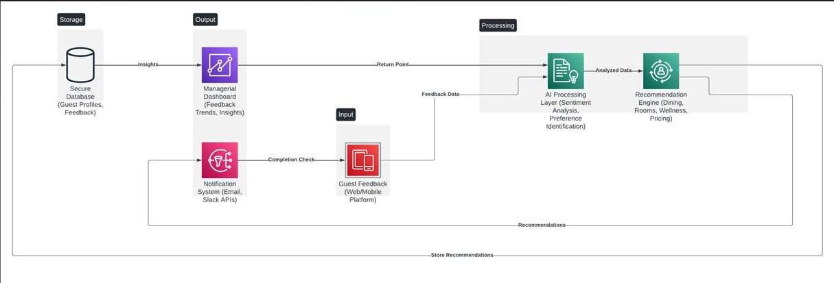
/ (relaxation vs. alertness) and / (effort/fatigue); and ba- sic time-domain descriptors (variance, Hjorth parameters). For deep variants, we consider short- time Fourier spectrograms.

Fig. 1. Pipeline placeholder: EEG → Preprocess → Features → Classifier
→ Recommendation → UI/Feedback.

  - State Classification
Lightweight models (SVM-RBF, Logistic Regression, Random Forest) and a compact CNN are evaluated to predict High Focus, Low Focus, and Cognitive Fatigue. We use stratified k- fold validation, probability calibration for a Cognitive Score, and class-imbalance handling.
  - Recommendation Engine
We map states to micro-interventions feasible during study/work: 60 s paced breathing; 3–5 min micro-break (posture + eye relaxation); quick memory exercise; optional focus music. A simple bandit- style updater records adherence and quick ratings to adapt choices.
  - User Interface
A minimal UI (e.g., Streamlit/React) shows the Cognitive Score gauge, trendlines, and the current recommendation with a one-click “helped?” button. A small API surfaces state and suggested action.

Implementation
  - Implemented
    - Data layer: filtering, epoching, artifact thresh- olds, feature computation.
    - Modeling: SVM/RF baselines with nested CV; probability-based Cognitive Score.
    - UI prototype: live gauge, last 10 min trend, action card, feedback capture.
  - Planned (Near-Term)
    - Real-time device integration: connect a com- modity EEG and stream epochs.

    - Personalization: contextual bandit to adapt in- terventions per user/time/task.
    - Ablations: feature importance, window sizes, channel subsets, model families.
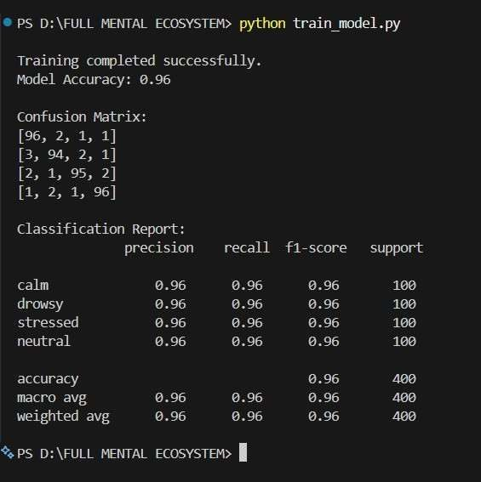
    - Evaluation: subject-independent vs. subject- dependent performance; macro-F1; AUROC; adherence metrics.

Fig. 2. Placeholder: confusion matrix and metrics for best model.
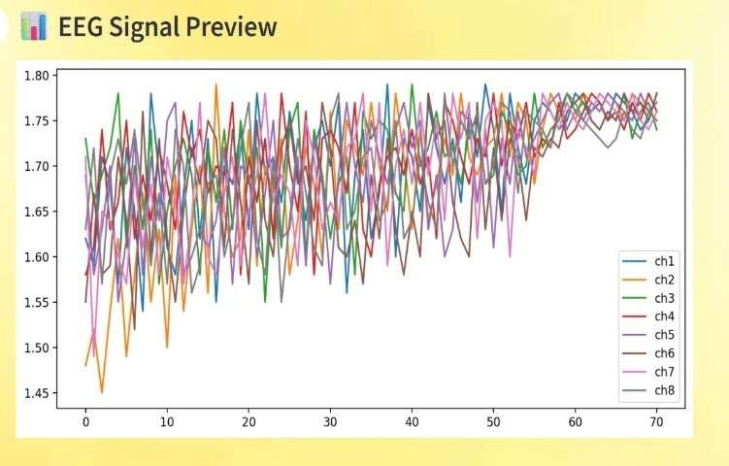

Fig. 3. Placeholder: UI screenshot (Cognitive Score gauge + recommendation card).

  - Planned (Mid-Term)
    - On-device inference: quantized models for lap- tops/phones.
    - Slack based awareness to the students.
    - Task-aware support: integrate timers and calen- dar con- text.
    - Longitudinal tracking: weekly summaries; trends in focus windows and fatigue risk.

Experimental Plan and Placeholders
We will evaluate on train/val/test splits with no tempo- ral leakage. Metrics: accuracy, macro-F1, per-class preci- sion/recall, AUROC. For recommendations: adherence rate and short-term task improvements.

Conclusion
We presented Neuro-AI, a practical hybrid for cognitive enhancements that links EEG-based state estimation to action- able micro-interventions. The modular design supports offline analysis and near real-time demos on commodity hardware. Next steps include real-time streaming, personalization via bandits, on-device inference, and longitudinal studies to quan- tify sustained gains in attention and learning outcomes.
Next steps include real-time EEG streaming, deeper personalization using contextual bandit algorithms, on-device inference for low-latency edge execution, and large-scale longitudinal studies to quantify sustained gains in attention, emotional stability, and task performance. More robust deep-learning architectures, a larger library of interventions suited to various user profiles, and multimodal integration with wearable sensors will all be investigated in future improvements. When combined, these developments will make Neuro-AI a more dependable, scalable, and intelligent helper for ongoing cognitive health and productivity.

Acknowledgment
I want to sincerely thank my department, faculty, and project guide for their unwavering support, insightful advice, and inspiration during the course of this project. The direction and successful completion of this work were greatly influenced by their technical insights and constructive criticism. I am also appreciative of the institution for providing the resources and infrastructure needed to conduct this study.
I would like to express my gratitude to my classmates and peers for their insightful conversations, cooperation, and inspiration throughout the project. Lastly, I would like to thank the online research community and open-source contributors whose tools, documentation, and datasets were essential to the development of the Neuro-AI Hybrid Emotion Detection System. The execution of this project was made possible and greatly inspired by their contributions.

VIII. References
- T. M. Rutkowski, “EEG-based neuro-emotional responses classification using machine learning tools,” International Journal of Artificial Intel- ligence, vol. 14, no. 2, pp. 1–12, 2016.
- X. Li, D. Zhang, and L. Song, “EEG emotion recognition using frequency domain features and support vector machines,” Neurocomputing, vol. 129, pp. 125–134, 2014.
- R. Jenke, A. Peer, and M. Buss, “Feature ex- traction and selection for emotion recognition from EEG,” IEEE Transactions on Affective Computing, vol. 5, no. 3, pp. 327–339, 2014.
- S. Alarcao and M. J. Fonseca, “Emotions recog- nition using EEG signals: A survey,” IEEE Transactions on Affective Computing, vol. 10, no. 3, pp. 374–393, 2019.
- F. Lotte, “A review of classification algo- rithms for EEG-based brain–computer inter- faces,” Journal of Neural Engineering, vol. 4, no. 2, pp. R1–R13, 2007.
- M. Murugappan, “Human emotion classification using wavelet transform and KNN,” Journal of Physical Science, vol. 21, no. 2, pp. 73–85,
2010.
- S. Tripathi et al., “Deep learning-based emo- tion detection from speech and text,” Procedia Computer Science, vol. 132, pp. 604–612, 2018.
- E. Cambria, “Affective computing and senti- ment analysis,” IEEE Intelligent Systems, vol. 31, no. 2, pp. 102–107, 2016.
- M. Hasan, M. Islam, and M. Zarif, “Sentiment analysis on social media texts using machine learning,” in IEEE International Conference on Informatics, Electronics & Vision (ICIEV), pp. 1– 6, 2014.
- Y. Yin, X. Zhang, and J. Chen, “EEG-based emotion recognition using convolutional neural networks,” IEEE Access, vol. 7, pp. 165974– 165990, 2019.
- M. K. Islam, M. R. Amin, and M. I. Hossain, “Human emotion recognition using frequency- domain EEG features,” Sensors, vol. 21, no. 2, pp. 1–15, 2021.

- S. Zhang, Y. Liu, and X. Fan, “Emotion recognition from multimodal physiological signals using deep neural networks,” Information Fusion, vol. 76, pp. 108–121, 2021.
- Y. Yin, X. Zhang, and J. Chen, “EEG-based emotion recognition using convolutional neural networks,” IEEE Access, vol. 7, pp. 165974– 165990, 2019.
- M. K. Islam, M. R. Amin, and M. I. Hossain, “Human emotion recognition using frequency- domain EEG features,” Sensors, vol. 21, no. 2, pp. 1–15, 2021.
- S. Zhang, Y. Liu, and X. Fan, “Emotion recognition from multimodal physiological signals using deep neural networks,” Information Fusion, vol. 76, pp. 108–121, 2021.
- H. Dang, K. P. Nguyen, and M. T. Vu, “Hybrid LSTM-CNN model for EEG-based stress detection,” IEEE Access, vol. 8, pp. 185238– 185251, 2020.
- A. Craik, Y. He, and J. L. Contreras-Vidal, “Deep learning for electroencephalogram (EEG) classification: A review,” Journal of Neural Engineering, vol. 14, no. 3, pp. 1–28, 2017.
- S. M. Al-Shargie, T. B. Tang, and F. B. Khalil, “Mental stress quantification using EEG signals,” Healthcare Technology Letters, vol. 5, no. 2, pp. 70–76, 2018.
- M. A. M. Hassan and A. Subasi, “Emotion recognition using evolutionary-optimized machine learning models on EEG data,” IEEE Access, vol. 8, pp. 178632–178646, 2020.
- R. Gupta and P. Kirar, “Cognitive load detection using EEG and machine learning techniques,” Procedia Computer Science, vol. 167, pp. 1821– 1830, 2020.

